**GUVI WEBSITE DOCUMENTATION**

1. This is the home page. It contains the login and signup link in the navbar in order to login and register.



1. Click on the signup button to register. This will take u to the signup page.
2. The user should enter the details needed for registration and give signup.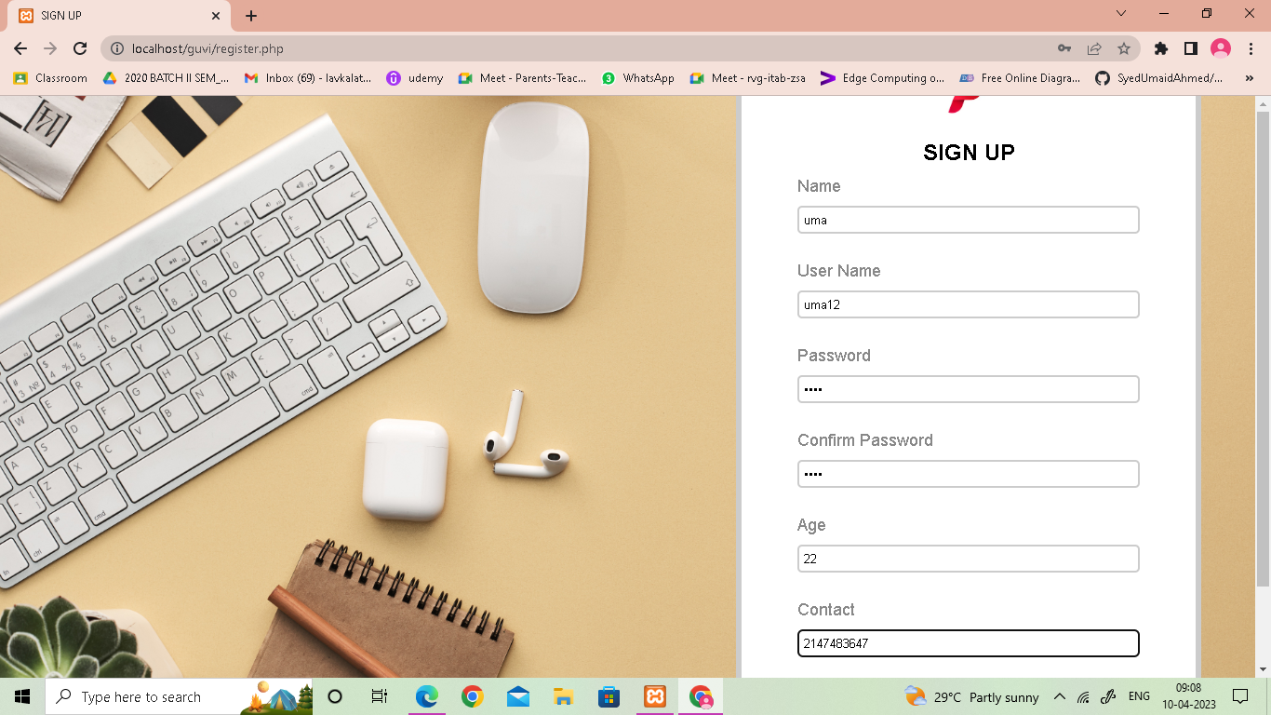

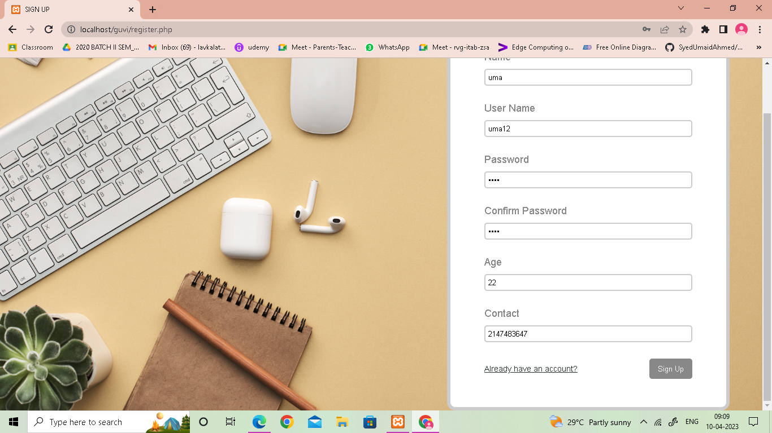

4) After the successful registration, the user will be displayed with the message like "your account has been created successfully".

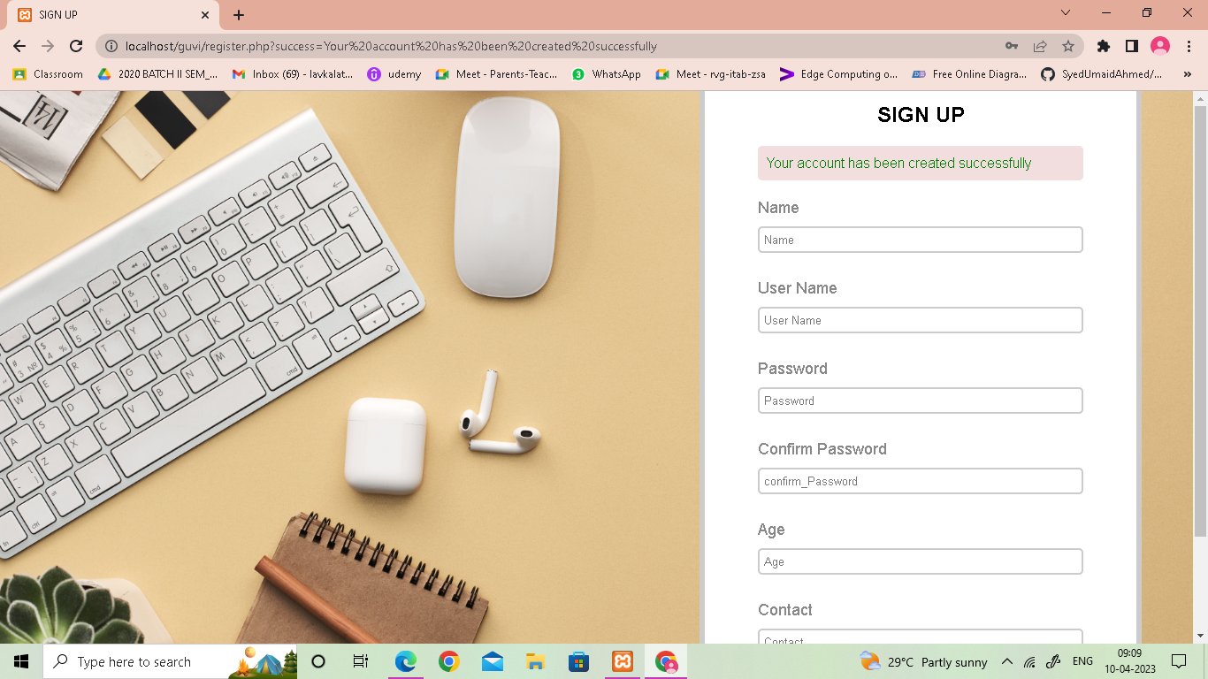

5)In the home page, if u click on login, u will be taken to login page.



6)Now enter the username. If u don't give the required fields it will throw u error message because i have attached the form validation.

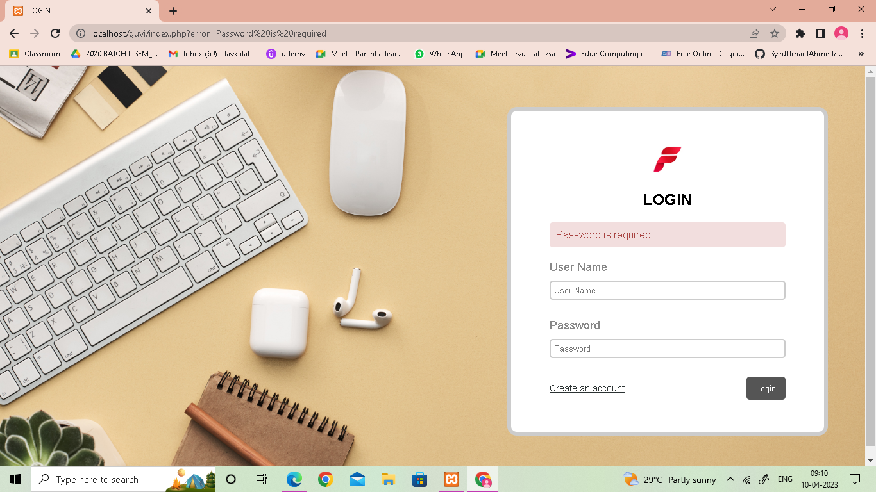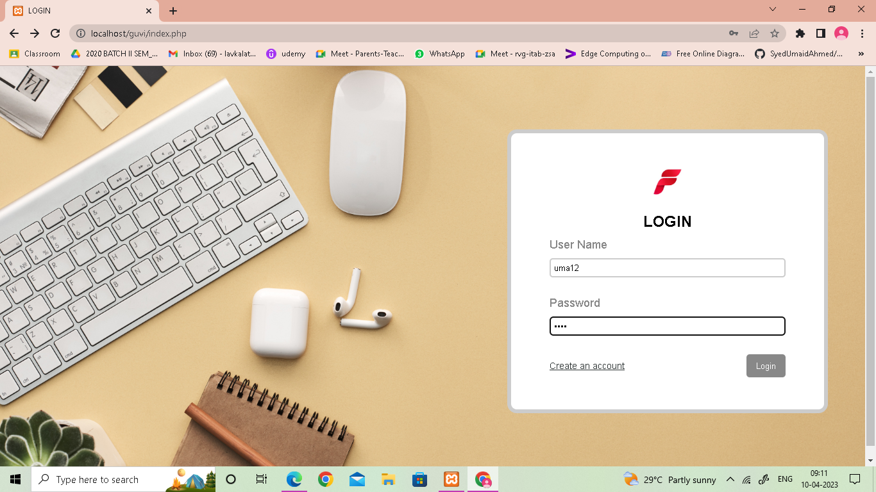

7)After successful login, this will take u to the profile page where u will see all ur personal details u gave.



**8) If i give logout this will take the user to the home page.**

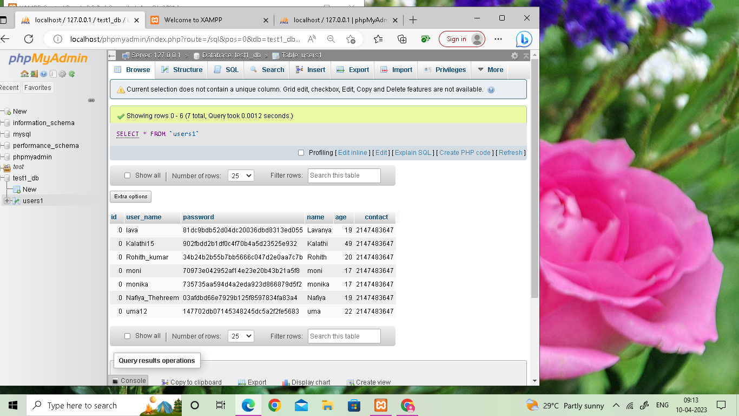9)If I check in MySQL database the user data would be added.